|  |
| --- |
| GDT4-2021 |
| Pilgrimage |
| 10-Page Design Document |

|  |
| --- |
| Your Own Game 5  3-14-2021 |

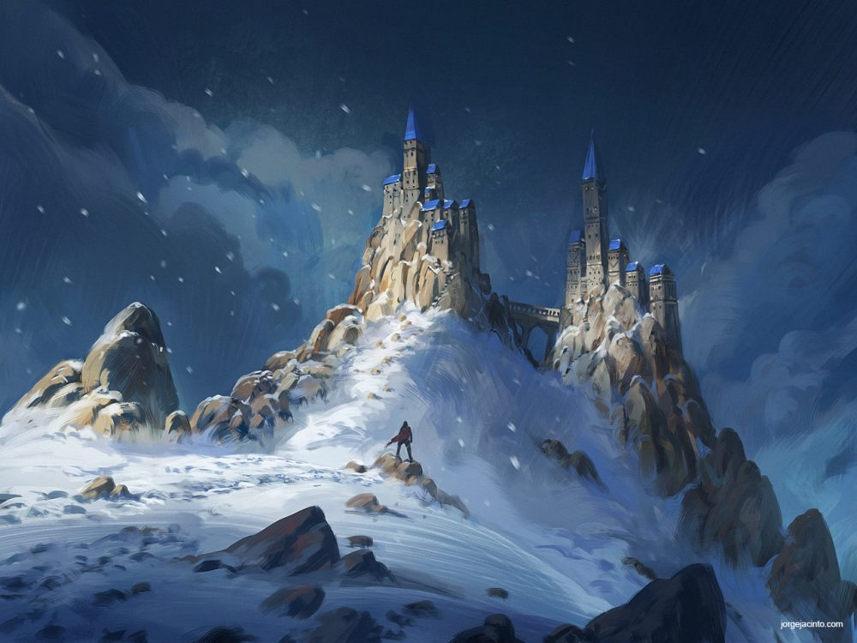

# Game Description

## Game Story:

In a world full of mysteries and monsters, the traveler ventures beyond the safety of his town, Seliana, to fulfill his brother’s dying wish, to have his remains scattered alongside his family. Join the traveler’s journey as he faces unfathomable creatures, reminisce his old memories, and treacherous paths as he fulfills his brother’s final wish.

Follow the traveler as he grows as a person and learn to deal with the loss.

## Game Play:

The traveler is a very agile and meticulous adventurer and that is shown in his controls. Players will enjoy a high skill-cap fast paced movement system that will make the player feel good when traversing the levels. The movement system is inspired by the Titanfall series and Ghostrunner. The world is a hybrid of Open-World and Theme-park inspired by Tombraider and Ashen and will offer parkour challenges, dangerous enemy encounters, light navigation puzzles and well kept secrets.  
  
In order for The Traveler to complete his brother’s wish he will need to acquire a set amount of key items from different types of trials. These can include but are not limited to: Parkour challenges and puzzles. Along the way, players will encounter deadly enemies and monsters, and, as the traveler is no fighter, players will have to sneak their way from the enemy’s territory, as one mistake could be the player’s last.

## Unique Selling Points:

* Fluid movement mechanics
* Acquire progressively stronger weapons and abilities
* Beautiful Stylized World
* Deep and engaging story
* Encounter unique monsters and enemies
* 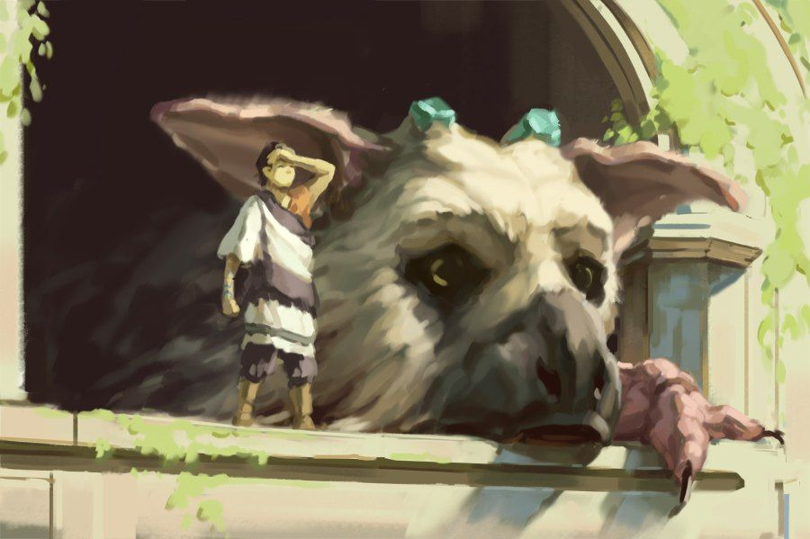Various stealth mechanics to sneak through enemies

# Game Design

## Player Character:

Meet the Traveler a brave adventurer from the town of Seliana, whom shall fulfill his brother’s dying wish. Equipped with a bow and acrobatic skills, he must venture through the beautiful yet treacherous lands of the kingdom Valaris. On his path, he will face many dangerous mountain passes, deadly beasts, and many secrets in which the kingdom holds.

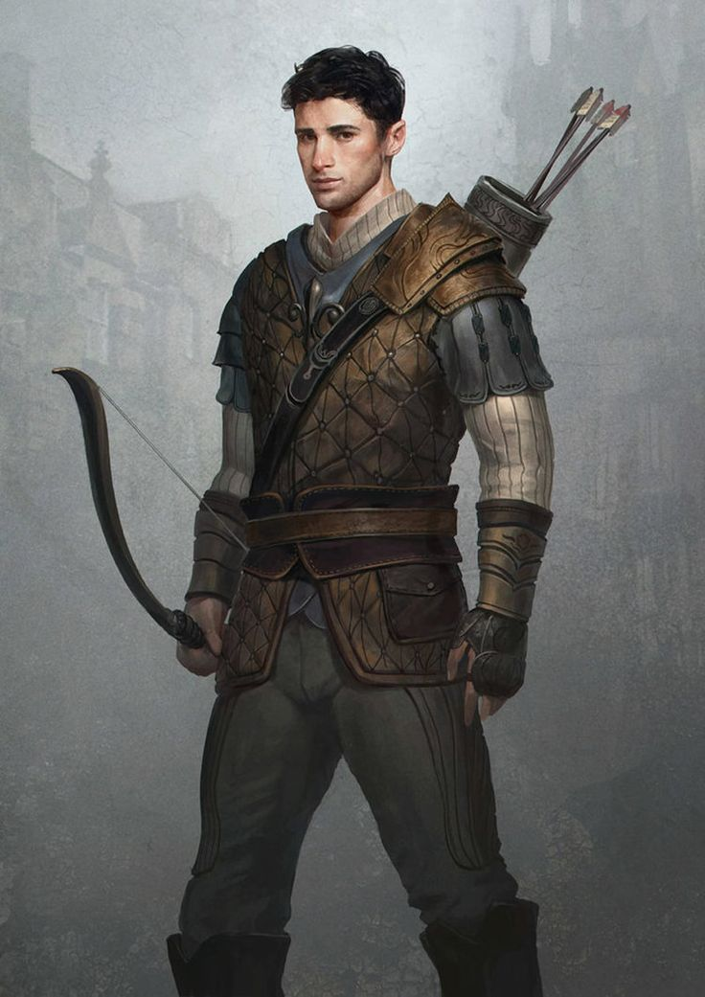

## World:

The kingdom of Valaris is a beautiful yet mysterious kingdom, filled with many dangers and wonders blessed by nature itself, scattered across the lands. The Journey to <designated location> is filled with many mysterious and dangerous path, with monsters that lurks in every corner of the land. The traveler will discover many mountainous path and old ruins as he travels to the <Designated location>.

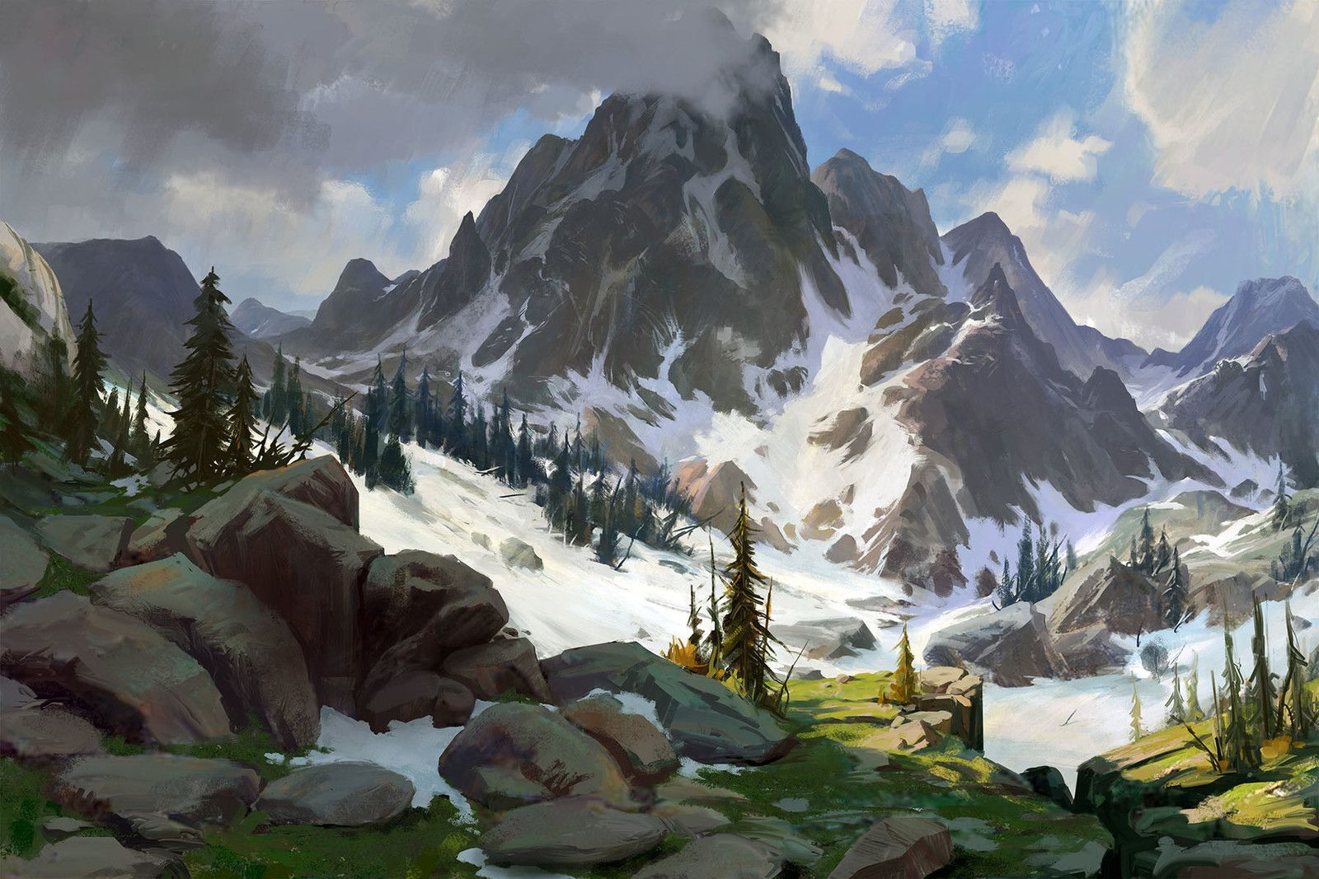

## Enemies:

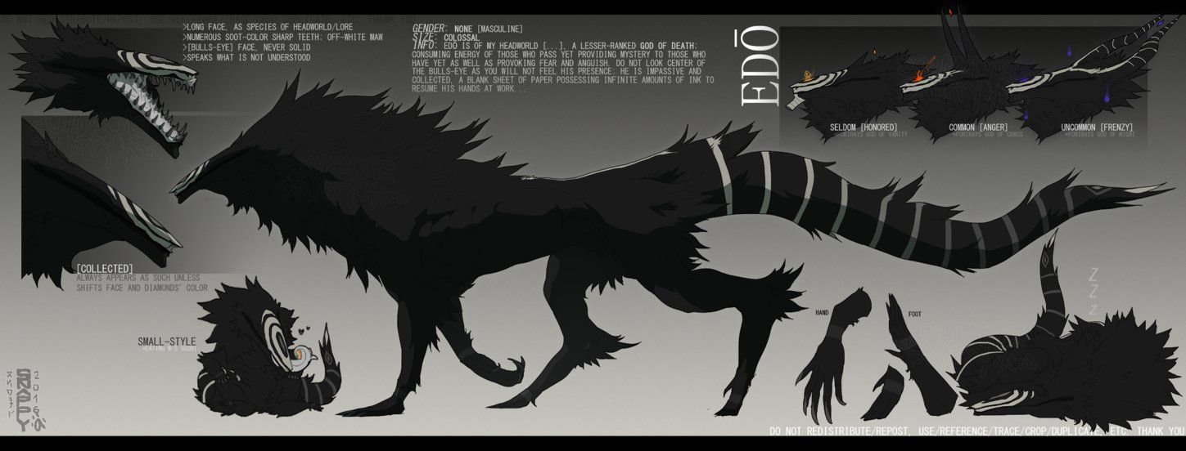The monsters that lurks in the corner of the Kingdom of Valaris are known as beasts of the old. Legend says that they have exist long before civilisation exists in that Kingdom. They are fierce creatures with deadly strength and agility, and with its thick hide and skin, they are invulnerable to any physical attacks. As the traveler, he must avoid contact at all cost if he were to value his life and if he were to fulfil his brother’s wish.

## Secrets:

The Kingdom of Valaris is filled with many mysteries and secrets. As the traveler ventures to <Designated location>, he will be met with many secrets that he must solved in order to help him on his journey. In addition, the secrets that he solves may contain stories of the old civilization that tells the lore and ways of the first civilization that exists on the Kingdom.

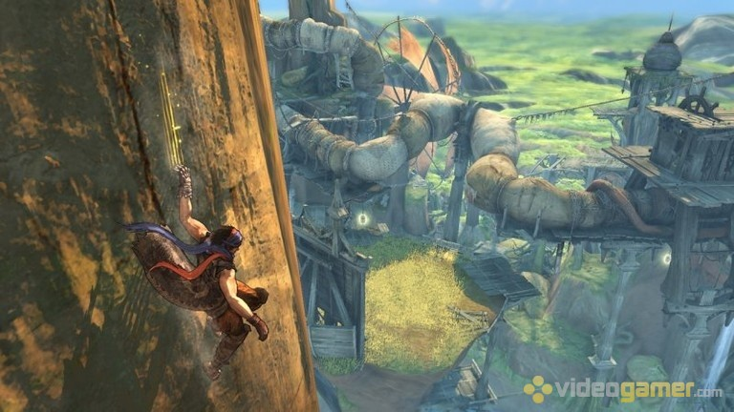

# Game Mechanics

## Wall-running:

The wall-running is the core mechanic in our movement system. This is inspired by the works of respawn entertainment Titanfall series. So the idea is to give players a more fluid movement in the game because the movement system needs to give players an easier way to explore the world of Pilgrimage, since the world is made up of many mountainous paths.



## Bow:

The bow is used mainly for solving puzzles. The idea is that players will use the bow to shoot tiles or platforms with the bow to solve the puzzle. Of course the arrow will have a trajectory system in which the arrow will curve after a certain distance. This will make sure that the bow will feel more realistic to the players when they are using it.



## Puzzles:

There will be puzzles inside the game. As for now the puzzles are platforming puzzle, where players need to maneuver to get to one place from another (Similar to Uncharted). The other would be the shooting puzzle, using the bow to shoot tile or platform to open a door or create a platform. This is to make the journey of the game more interesting and more intuitive.



## No Combat:

There will be no combat in this game. Because of this, the players need to avoid being caught or detected by the enemies along the journey, otherwise they will be killed. The idea is to give players the sense of danger during enemy encounters.





Of course to do this, there will be a detection system for the enemies. The stages of detection is as follows:

